Flutter Fundamentals

## Dart Language

Flutter uses Dart, a client-optimized language for fast apps on any platform. It's important to grasp Dart's syntax and features, including async-await, streams, and its strong typing system.

## Widgets

Everything in Flutter is a widget. Widgets can be structural (like containers, rows, columns) or stylistic (like text, buttons). Understanding how to compose widgets to build your UI is crucial. Widgets can be stateless (immutable state) or stateful (mutable state).

## Widget Tree

Flutter builds its UI based on a hierarchy of widgets. Understanding how to structure your widget tree efficiently is crucial for building complex layouts.

## Layouts

Flutter provides various layout widgets like Container, Row, Column, Stack, etc., to arrange other widgets on the screen. Mastering layout widgets and understanding how to nest them efficiently is important.

## State Management

Flutter provides several options for managing state in your application, such as setState, Provider, Bloc, Riverpod, etc. Choose the one that fits your project's needs best and learn to use it effectively.

## Navigation

Navigating between screens is a fundamental aspect of mobile app development. Flutter's Navigator class helps manage routes and transitions between screens.

## Asynchronous Programming

Many operations, such as network requests, are asynchronous. Dart's Future and Stream make handling async operations easier.

## Animations

Flutter has a powerful animations framework that allows for smooth and complex UI animations.

## Theming

Flutter allows you to create themes for consistent styling across your app. Understanding how to define and apply themes will make your app look polished and professional.

## Assets

Managing assets such as images, fonts, and other resources is essential. Flutter makes it easy to include and use assets in your application.

## Packages

Flutter's package ecosystem is vast and provides solutions for various functionalities. Learn how to use pub.dev to find and integrate packages into your project.

## Platform Integration

Flutter allows you to integrate platform-specific code (Android, iOS) using platform channels. Understanding how to communicate between Flutter and native code is important for accessing device features not directly supported by Flutter.

Best Practices

## State Management

Choose a state management approach that suits your app size and complexity. Use Provider or Riverpod for most cases, but consider more robust solutions like Bloc for larger apps.

## Code Organization

Organize your code into folders based on features or functionality. This makes your codebase easier to navigate and maintain.

## Reusable Widgets

Create reusable widgets to avoid code duplication and improve maintainability.

## Use Stateless Widgets Whenever Possible

Stateless widgets are simpler and more efficient than stateful widgets. Reserve stateful widgets only for components that genuinely need to manage state.

## Follow the Widget Lifecycle

Understand the lifecycle of stateful widgets and manage resources efficiently to avoid memory leaks and performance issues.

## Efficient Widget Trees

Minimize deep widget trees and avoid unnecessary widgets to improve performance.

## Keep the UI Responsive

Offload intensive operations to background threads using Dart's isolates to keep the UI smooth and responsive.

## Responsive Design

Design your UI to adapt to different screen sizes and orientations. Flutter's layout widgets and MediaQuery can help achieve responsive designs.

## Testing

Write unit, widget, and integration tests to ensure your app works as expected and to catch bugs early. Flutter provides tools like flutter_test package and flutter_test library for testing.

## Follow the Flutter Style Guide

Adhere to Flutter's style guide and best practices to make your code cleaner and more maintainable.

## Performance Profiling

Use Flutter's performance profiling tools to identify and fix bottlenecks in your app. Optimize your code and UI to ensure smooth performance.

## Keep Up with Updates

Flutter is continuously evolving. Stay updated with the latest features and improvements to take advantage of new optimizations and tools.

## Internationalization and Localization

Supporting multiple languages makes your app accessible to a wider audience by implementing internationalization and accessibility features. Flutter provides built-in support for both.

## Code Readability and Documentation

Write clean, readable code and document it properly. Follow Dart's style guide and use meaningful variable and function names.

Key aspects of the Flutter Style Guide

<https://github.com/flutter/flutter/wiki/Style-guide-for-Flutter-repo>

## Code Formatting

* The Flutter Style Guide recommends using the official dartfmt tool to automatically format your Dart code according to the Dart style guide.
* It specifies rules for indentation, spacing, line lengths, and other formatting conventions.

## Naming Conventions

* Class names should use UpperCamelCase.
* Variable and function names should use lowerCamelCase.
* Constant names should be all_uppercase_with_underscores.
* Prefixes like _ for private members and k for constant values are commonly used.

## Widget Structure

* Widgets should be split into smaller, reusable components for better maintainability and testability.
* Each widget should have a single responsibility (e.g., UI rendering, state management, or business logic).
* Widget constructor parameters should be kept concise and well-documented.

## State Management

* The Flutter Style Guide recommends following the recommended state management practices for Flutter, such as using StatefulWidget or state management solutions like Provider, BLoC, or Riverpod.
* It provides guidelines for structuring state management code and separating concerns.

## Asynchronous Programming

* The style guide covers best practices for working with async/await, Futures, and Streams.
* It suggests ways to handle errors and handle loading states in UI components.

## Dependency Injection

* The Flutter Style Guide promotes the use of dependency injection for better code organization, testability, and maintainability.
* It provides examples of how to implement dependency injection in Flutter applications.

## Testing

* The style guide emphasizes the importance of writing tests and provides guidelines for writing effective unit, widget, and integration tests.
* It covers techniques for mocking dependencies and testing asynchronous code.

## Documentation

* The Flutter Style Guide recommends documenting code using Dart's documentation comments (///).
* It suggests best practices for writing clear and concise documentation for classes, methods, and parameters.

## Accessibility

* The style guide promotes practices for making Flutter applications accessible to users with disabilities, such as using semantic markup, providing proper labeling, and following accessibility guidelines.

## Performance Optimization

* The Flutter Style Guide covers techniques for optimizing Flutter applications, such as reducing widget rebuilds, lazy loading, and efficient data handling.

Understanding BLoC

## The BLoC pattern consists of the following components:

1. Presentation Layer (UI): This layer contains the widgets responsible for rendering the user interface and handling user interactions.
2. BLoC (Business Logic Component): This component encapsulates the business logic and manages the application state.
3. Events: Events are actions or user interactions that trigger state changes in the BLoC.
4. States: States represent the current state of the application or a specific feature.
5. Sink: The sink is used to add events to the BLoC.
6. Stream: The stream is used to listen for and receive states from the BLoC.

## Implementing

To implement the BLoC pattern in Flutter, we'll use the bloc package, which provides a solid foundation for building BLoCs.

1. Install Dependencies: First, add the bloc package to your pubspec.yaml file.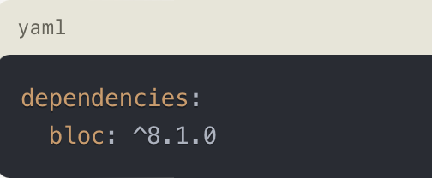
2. Create the BLoC: Create a new class that extends Bloc<Event, State>. This class will encapsulate the business logic and manage the application state.

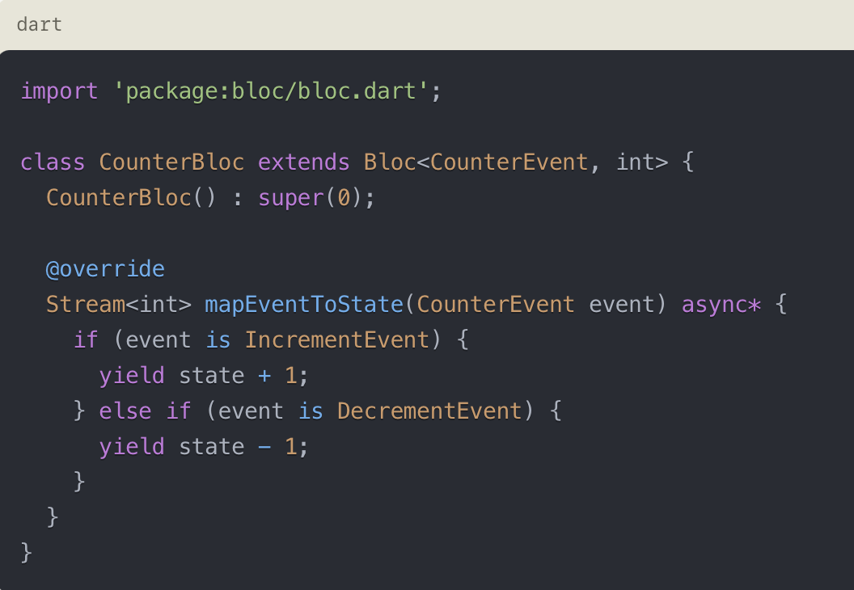

1. Create Events: Events represent actions or user interactions that trigger state changes in the BLoC. Create classes that extend AbstractEvent to define your events.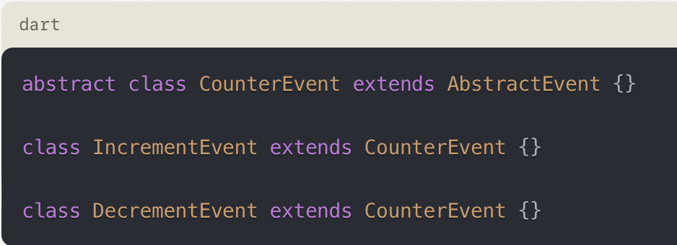
2. Provide the BLoC to the UI: To make the BLoC available to the UI layer, you need to provide it to the widgets that will consume it. You can use the BlocProvider widget from the flutter_bloc package to make the BLoC available to its child widgets.

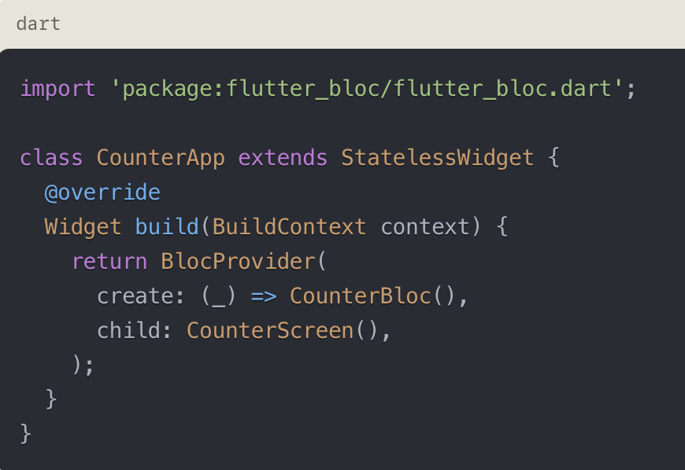

1. Consume the BLoC in the UI: In your UI widgets, you can use the BlocBuilder or BlocConsumer widgets to listen to state changes and rebuild the UI accordingly.

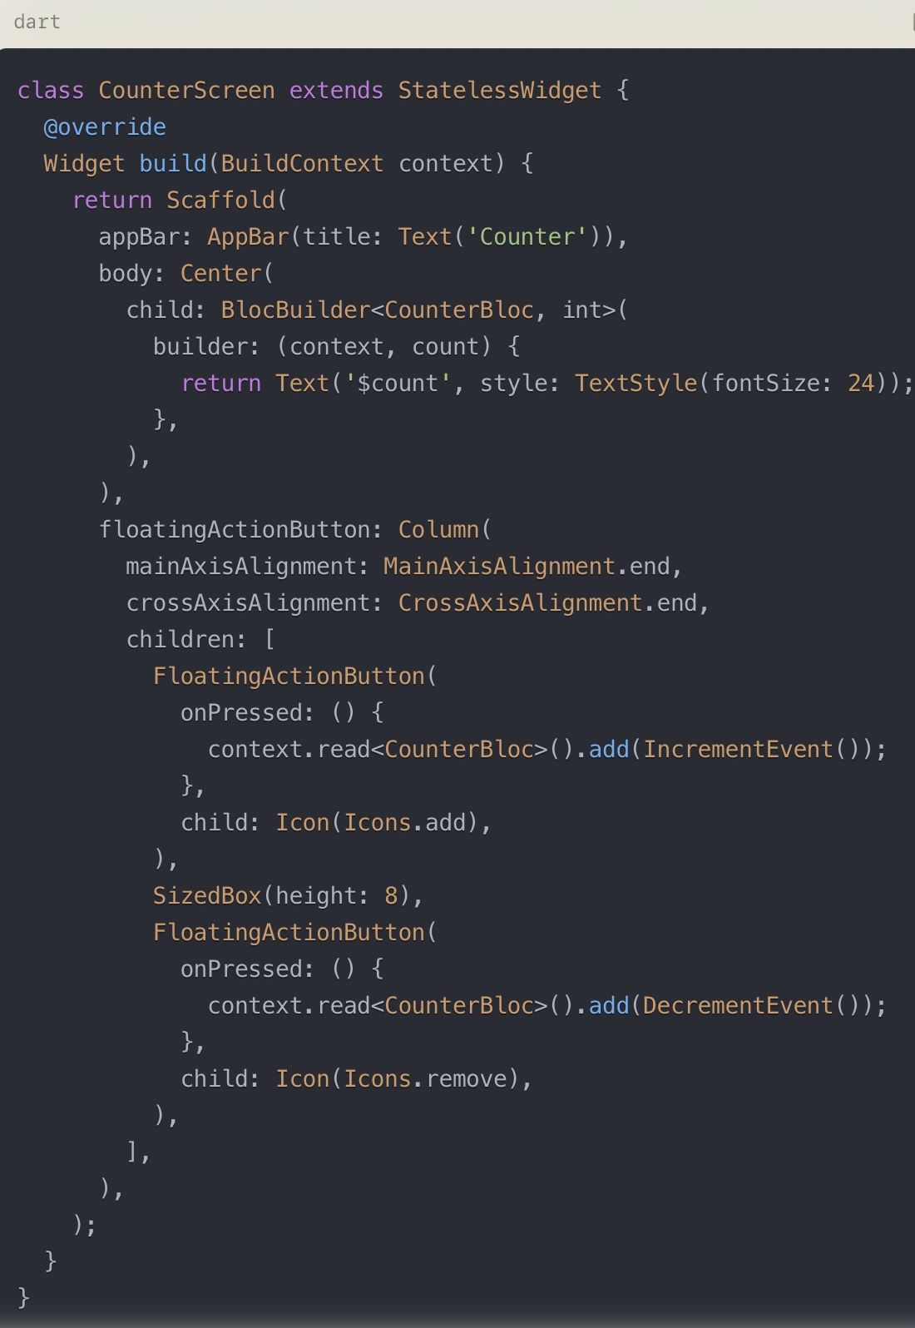

In this example, the CounterScreen widget uses BlocBuilder to rebuild the UI when the counter state changes. The floating action buttons add IncrementEvent and DecrementEvent to the CounterBloc using context.read<CounterBloc>().add(event).

## Advanced BLoC Usage

The bloc package provides additional features and utilities to enhance the BLoC pattern implementation:

1. BLoC Observers: You can use BlocObserver to observe and react to state changes, errors, and transitions in your BLoCs. This can be useful for logging, analytics, or error handling.
2. Cubit (Simpler BLoC): The Cubit is a variation of the Bloc that simplifies the pattern by removing the need for explicit events. It exposes a single state stream and provides methods to update the state directly.
3. BLoC Transformers: You can use BlocTransformer to modify the behavior of a BLoC by transforming the incoming events or outgoing states.
4. BLoC Delegation: You can use BlocDelegate to reuse and compose different BLoCs together, promoting code reusability and modularity.
5. BLoC Test Helpers: The bloc package provides utilities for testing BLoCs, such as blocTest and blocTest<BlocType, State>, which simplify the testing process.

## Best Practices

When implementing the BLoC pattern in Flutter, it's recommended to follow these best practices:

* Separate Concerns: Separate the presentation layer (UI) from the business logic layer (BLoC) to promote code reusability and maintainability.
* Immutable States: Treat states as immutable objects to ensure predictable state transitions and avoid side effects.
* Unit Testing: Write unit tests for your BLoCs to ensure the correctness of the business logic and state transitions.
* Widget Testing: Write widget tests to verify the UI behavior when interacting with the BLoC.
* Code Organization: Organize your BLoCs, events, and states in separate files or directories for better code structure and maintainability.
* Error Handling: Implement proper error handling mechanisms in your BLoCs to handle and propagate errors appropriately.
* Performance Optimization: Optimize your BLoCs by avoiding unnecessary state updates, leveraging BLoC transformers, and using appropriate concurrency strategies (e.g., asynchronous or synchronous events).